DON BOSCO INSTITUTE OF TECHNOLOGY
Premier Automobiles Road, Kurla (W), Mumbai-70

Approved by AICTE, Govt. of Maharashtra
&
Affiliated to the University of Mumbai



B.E. PROJECT REPORT “I”

On

“Design And Implementation of In-Memory Database
System For efficient Information retrieval”

Department of Computer Engineering
University of Mumbai
2019-2020
Project Title : Design and implementation of In-memory database
system for efficient information retrieval.

Organization : Don Bosco Institute of Technology

Address : Premier Automobiles Road,
Kurla (W), Mumbai-70

Project Team Members : 1. Diana Dsouza
2. Aishwarya Jadhav
3.Tooba Khan

Internal Guide : Dr. Phiroz Shaikh

Address : Department of Computer Engineering,
Don Bosco Institute of Technology,
Premier Automobiles Road,
Kurla (W), Mumbai-400070

____________________
INTERNAL GUIDE (s)

____________________
HEAD, COMPTUER ENGINEERING

CERTIFICATE

This is to certify that the following project members of final year class have satisfactorily completed the PROJECT- I report on Design and Implementation of In-memory Database system for efficient information retrieval in the partial fulfillment of the Computer Engineering course of Bachelor of Engineering of the Mumbai University during July to October 2019.

Project Team Members:

1. Diana Dsouza B. E. – (22)
2. Aishwarya Jadhav B. E. – (28)
3. Tooba Khan B. E. – (32)

___________________ ____________________

INTERNAL EXAMINER EXTERNAL EXAMINER

ABSTRACT

In Memory Database also known as Main Memory database is a database where the data relies on RAM making the operations of database efficient. These systems allow users to run queries and reports on the information contained, which is regularly updated to incorporate recent transaction data from an organization's operational systems.
The purpose of this project is to minimize the access time of various database operations like read,update and delete and comparing the access time required for querying on secondary storage and on primary storage.
Applying suitable Data structure and indexing scheme are will help to efficiently retrieve data .Selection of appropriate programing language for both primary and secondary storage is the must.
Result will be in the form of time that will be obtained by comparing various database operations performed on both primary and secondary storage.
IMDB's shows the great results when we deal with massive amount of data and we can retrieve data in short amount of time as compared to the secondary storage. Performing the operations on massive amount of data in a dataset and comparing the access time.

TABLE OF CONTENTS
Sr. No. | Contents | Page no.
Chapter 1 | Introduction
Chapter 2 | Literature Survey
Chapter 2 | 2.1 Survey Existing system
Chapter 2 | 2.2 Limitation Existing system or research gap
Chapter 2 | 2.3 Problem Statement and Objective
Chapter 2 | 2.4 Scope
Chapter 3 | Proposed System
Chapter 3 | 3.1 Analysis/Framework/ Algorithm
Chapter 3 | 3.2 Details of Hardware And Software
Chapter 3 | 3.3 Design Details
Chapter 3 | 3.4 Methodology (your approach to solve the problem)
Chapter 4 | Implementation
Chapter 4 | 4.1 Implementation Plan for next semester
 | Conclusion
 | References
 | Appendix
 | Acknowledgement

CHAPTER 1 : INTRODUCTION
What is IMDB?
. An In- Memory database(IMDB, also known as a main memory database or MMDB) is a database whose data is stored in main memory to facilitate faster response times.
. An IMDB is a type of Analytic database, which is a read-only system that stores historical data on metrics for business intelligence/business analytics applications, typically as part of a data warehouse or data mart. These systems allow users to run queries and reports on the information contained, which is regularly updated to incorporate recent transaction data from an organization's operational systems.
Why?
- Real time data
- Main memory is way faster than any disk
- Fewer CPU instructions
- Internal optimization algorithms are much simpler

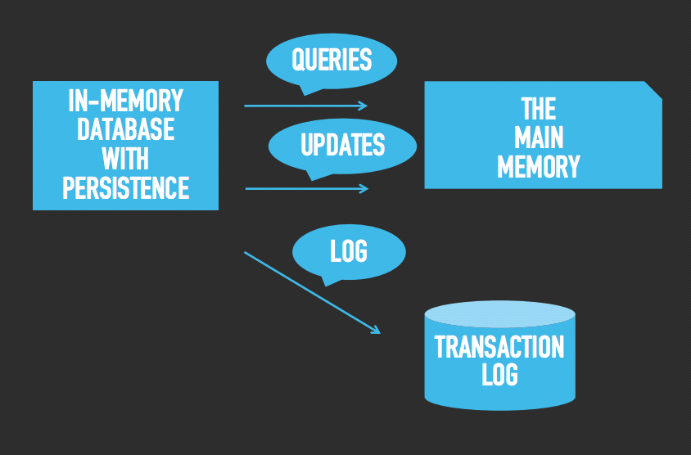

CHAPTER 2 : literature survey
IEEE Papers:
Sr no. | Papers | Authors | Publication Year
1. | A performance evaluation of in-memory databases | Abdulla Talha Kabakus,  Resul Kara | 2016
2. | In-Memory Big Data Management and Processing: A Survey | Hao Zhang, Gang Chen, Beng Chin Ooi | 2015
3. | In-Memory Distributed Indexing for Large-Scale Media Data Retrieval | Yinmiao Ma , Danlu Liu ,Grant Scott,Jeffrey Uhlmann,Chi-Ren Shyu | 2017
4. | Improving In-memory Database Index Performance with Intel Transactional Synchronization Extensions. | Tomas Karnage,  Ravi Rajwar,  Roman Dementiev  Konrad Lai | 2014
5. | IBM solidDB: In-memory Database Optimized for Extreme Speed and Availability | Jan Lindström, Vilho Raatikka, Jarmo Ruuth, Petri Soini | 2013

1st paper:
A performance evaluation of in-memory databases
This paper shows the experiment of widely used in-memory databases to measure their performance in terms of (1) the time taken to complete operations, and (2) how efficiently they use memory during operations. Various databases used in this experiments are MongoDB, Redis, Memcached, Cassandra are NoSQL databases and one that is H2 that is intentionally included into list despite that is RDBMS. Therefore, the experimental results reveal the effect of the database model on the performance of database.
Experimental set-up:
1.Operating System: Ubuntu 14.04(64-bit)
2.Memory: 16GB
3.CPU: Intel Core i7
4.Java Version:1.8.0

They have developed their own software based on Java to measure performance of in-memory databases for various experiments. Execution time per operation is recorded by determining system time at the start and end of the method using java.lang.System class. Similarly,consumed memory per operation is recorded by method java.lang.Runtime class. During the experiments,all the other processes of operating system (except the mandatory ones) are stopped in order to reveal sole performance of databases.
Problem Statement:
- An experiment on various in-memory databases to measure the performance for different data operations.
- Developing a software that measures a performance in terms of time taken and how efficiently databases use memory during operations.
Future Scope:
- The effect of document types on performance for each database can be experimented.
- Reasons of latencies that are experienced during the experiments can be explained in detail by inspecting database architectures.
Critical Analysis: As explained in this paper that in-memory database are either NoSQL, RDBMS ,etc. Where NoSQL DB shows great results as compared to other DB. Therefore, using NoSQL database can be useful for retrieving data in short ample of time even when there is massive amount of data.
2nd Paper:
In-Memory Big Data Management and Processing: A Survey
In this paper, they have created a survey that provides a thorough review of a wide range of in-memory data management and processing proposals and system including both data storage systems and data processing frameworks like Hadoop,spark,Flink.
They have talked about indexes designed for in-memory database that they are different from traditional indexes designed for disk based databases such as B+ tree because traditional indexes mainly are about I/O efficiency instead of memory utilization.

This paper also talks about how IMDBS like Memcached,Redis uses Hash-based Indexes commonly for key-value stores.
Indexing:
- Indexing is used to optimize the performance of a database by minimizing the number of disk accesses required when a query is processed.
- The index is a type of data structure. It is used to locate and access the data in a database table quickly.
Critical Analysis:From this paper it can be concluded that using either Hash based indexes or B+ tree indexes as Data Structure are useful for efficient memory and cache utilization.
3rd Paper
In-Memory Distributed Indexing for Large-Scale Media Data Retrieval
In this paper, they’ve proposed a novel approach to speed up the retrieval process by adopting a distributed computing paradigm through the Spark Big Data framework. They've conducted computational experiments on large-scaled vector files(datasets) for remote sensing image database and synthesized pollen image database to demonstrate the effectiveness and scalability of thier system with reasonably high accuracy.The system described in this paper firstly reduces the performance time of searches. Secondly the system can be extended to different types of indexing structures and lastly for large-scale datasets this system significantly improves the performance while maintaining a high coverage ratio.
Experimental Requirements:
- Datasets used are:
1. set of 397 pollen images
2.set of 1.4M temporal satellite image chips
- CSV file(for storing Output)
- Spark Big Data Framework
Future Scope:
- In future work,they will utilize this system to various application domains, where the weighted-ranked results for searching similarities for large-scale datasets are required.
- Furthermore, additional indexing structures, both tree-based and hash-based, will be further studied.
Critical Analysis: It can be concluded that using tree-based Data structure can be used for efficient searching.
4th Paper
Improving In-memory Database Index Performance with Intel Transactional Synchronization Extensions
This paper evaluates the effectiveness of such hardware .This paper focuses on two index implementation:a B+ tree and Delta Storage Index. They have demonstrated that such support can improve performance of database data structures such as index trees.
Highlights the scalability issues that arise from contended atomic read-modify-write operations in modern high performance systems.
It also analyses concurrency behavior of two index implementation:A common B+Tree index and a more complex Delta Storage Index used in SAP HANA.
B+ Tree:
- In the B+ tree, every leaf node is at equal distance from the root node. The B+ tree is of the order n where n is fixed for every B+ tree.
- It contains an internal node and leaf node.
Experimental Requirements:
- 2-socket (Intel R Xeon CPU E5-2680) server system
- Intel 4th generation core Processor
- Linux operating System
Future Scope:
- Applying Intel TSX to other internal database data structures
Critical Analysis:Thus it can be concluded that if the database stores data in form of column structure Delta Storage Index would be efficient as used in SAP HANA otherwise B+ tree.

5th Paper
IBM solid DB: In-memory Database Optimized for Extreme Speed and Availability
This paper talks about how they have used IBM solid DB an in-memory database that is optimized for extreme speed and availability. This paper explores the structural differences between in-memory and disk based databases , and how solid DB works to deliver extreme speed.
This paper also talks about Vtrie indexes. This Vtrie is built on top of leaf node level very much similar to those used in B+ trees.
In solid DB, the main focus is on short response times that naturally results from the fact that the data is already in memory.
Also in addition,the advantages of solid DB in-memory database over a disk-based database,the response time is in milliseconds of single primary key fetch and single row update based on the primary key
Experimental Requirements:
- Computer
- IBM solid DB software
Future Scope:
- Analysis of other operations of database.
Critical Analysis: Solid DB gives short response time that is in milliseconds where this database uses Vtrie index that is built on leaf node similar to B+ tree.

Table of comparison:

Paper | Programing Interface/Software used | Data Structure/Indexing Technique Used/Mention--ed,etc | Output Achieved
1stpaper(A performance evaluation of in-memory databases) | Java Version:1.8.0 | Comparison of various IMDB | Memory usage,access time
2ndPaper(In-Memory Big Data Management and Processing: A Survey) | Available open Source IMDB software. | B+ tree and Hash based tree indexes. | Fault tolerance,  Indexes
3rdpaper (In-Memory Distributed Indexing for Large-Scale Media Data Retrieval) | Spark Big Data Framework | Tree based,Hash Based structure | Reduced search time,improved performance of large scale databases
4thpaper(Improving In-memory Database Index Performance with Intel Transactional Synchronizati Extensions.) | Intel 4thgeneration core processor,2 socket server system | Delta storage Index,B+ tree | Performance measure of database
5thpaper(IBM solidDB: In-memory Database Optimized for Extreme Speed and Availability | IBM solid DB | Vtrie Index | Calculating response time of read and update operations.

Problem Statement:
Designing the platform, which transfers data stored in secondary storage to RAM using appropriate Data Structure for fastest retrieval of data. Comparing access time between two data storage. Designing suitable indexing mechanism and suitable IMDB data structure for efficient data mapping information retrieval.
Objectives:
1. To retrieve data in short ample of time as compared to secondary storage.

2. To do data operations on both primary and secondary storage.

3. To compare the access time on both data storage.

Scope:
1. Increasing efficiency of database operations like read,update and delete.
2.Measuring database operations rate for IMDB and HDD stored database.

CHAPTER 3: proposed system
3.1 Analysis/Framework/ Algorithm:
Algorithms are used to minimize data access time and to store the data in primary memory .These algorithms also accomodate the operations like Insert, Update and Search. Project is basically depend on data structure. Data structure we are using is B+ trees. As it manipulate hierarchical data, make information easy to search, manipulate sorted lists of data.
Input : Dataset(xls file)
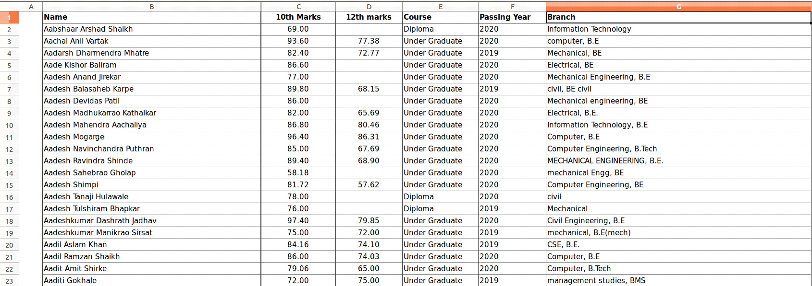
Indexing:
- Indexing is used to optimize the performance of a database by minimizing the number of disk accesses required when a query is processed.
- The index is a type of data structure. It is used to locate and access the data in a database table quickly.
Indexes can be created using some database columns.
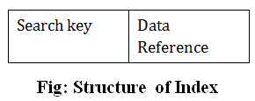
- The first column of the database is the search key that contains a copy of the primary key or candidate key of the table. The values of the primary key are stored in sorted order so that the corresponding data can be accessed easily.
- The second column of the database is the data reference. It contains a set of pointers holding the address of the disk block where the value of the particular key can be found.
Clustering Index:
- A clustered index can be defined as an ordered data file. Sometimes the index is created on non-primary key columns which may not be unique for each record.
- In this case, to identify the record faster, we will group two or more columns to get the unique value and create index out of them. This method is called a clustering index.
- The records which have similar characteristics are grouped, and indexes are created for these groups.
Dataset which we taken contains several student names. Suppose we use a clustering index, where all students have same initial characters in their name are considered within a single cluster, and index pointer point to the cluster as whole. Here name is non unique key.
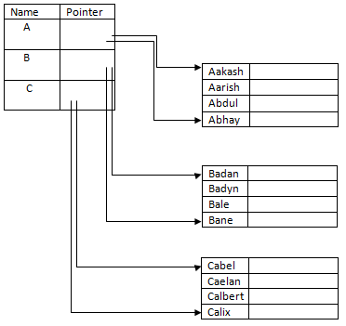

B+ Tree:
- The B+ tree is a balanced binary search tree. It follows a multi-level index format.
- In the B+ tree, leaf nodes denote actual data pointers. B+ tree ensures that all leaf nodes remain at the same height.
- In the B+ tree, the leaf nodes are linked using a link list. Therefore, a B+ tree can support random access as well as sequential access.
Structure of B+ Tree
- In the B+ tree, every leaf node is at equal distance from the root node. The B+ tree is of the order n where n is fixed for every B+ tree.
- It contains an internal node and leaf node.
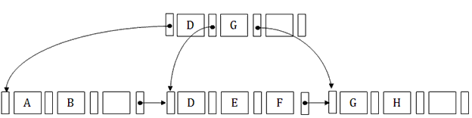
Hashing:
In a huge database structure, it is very inefficient to search all the index values and reach the desired data. Hashing technique is used to calculate the direct location of a data record on the disk without using index structure.
In this technique, data is stored at the data blocks whose address is generated by using a hashing function. The memory location where these records are stored is known as data bucket or data blocks.
We can even consider the primary key itself as the address of the data block. That means each row whose address will be the same as a primary key stored in the data block.
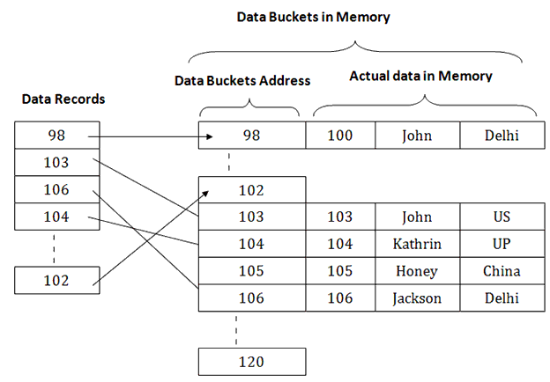
VBA Programming:
Excel VBA stands for Visual Basic for Applications. It is a programming language which is used to develop programs within Excel. It can turn complex or time-consuming tasks into automated processes, saving time and improving the quality of reporting.

Output:
As programming done on both the memory, output can be analysed on various cases. From above analysis, access time of both the database get compared for operations of insert, delete and search following table shows the comparison between access time of both database.
OPERATIONS | HDD | RAM
INSERT RECORD | ? | ?
DELETE RECORD | ? | ?
SEARCH RECORD | ? | ?

3.2 Details of Hardware And Software:
- System Requirements:
1.User :
User will query the data through the interface
2. Software Specification
Operating System: Windows 7/8/10,linux
Programming Interface:
❏ VBA programming.
❏ C program.
Dataset: Excel
3. Hardware Specification
a) RAM 2GB and more
b) Hard Disk
3.3 Design Details:
Application performs the insert ,delete and search operations on both data storage. The flow diagram respect to each operation is as follows:
- Flow diagram:
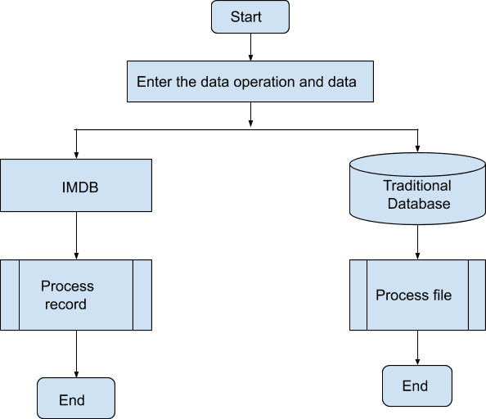
1.Search Operation:
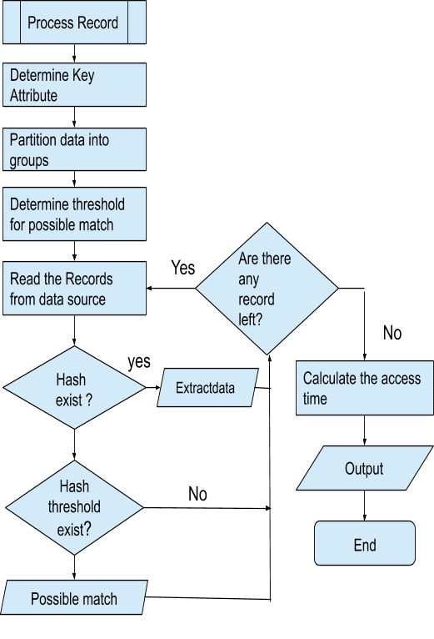
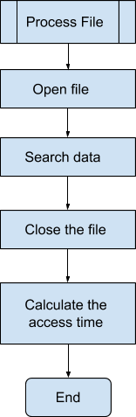
2.Insert operation:
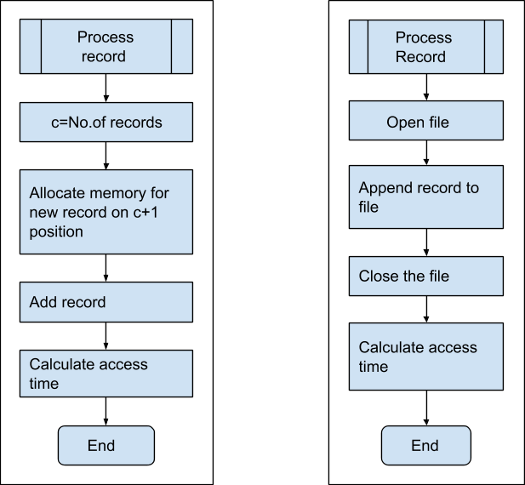

3.Delete operation:
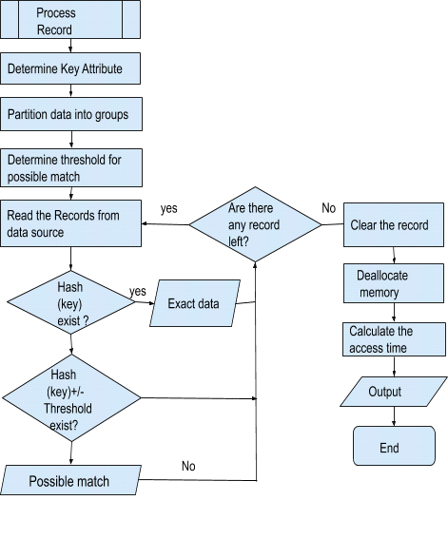

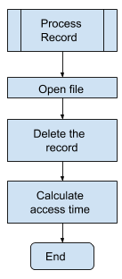
4.Framing Data structure:
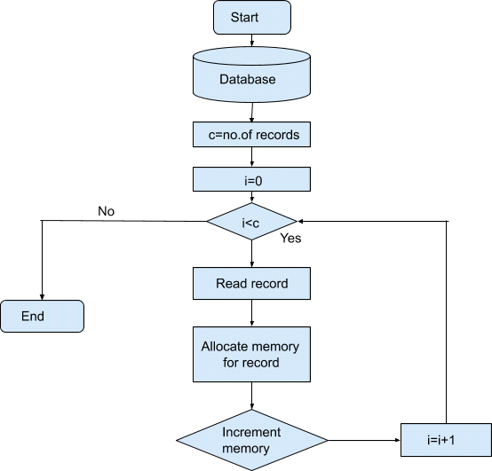

- Graph:
The advantages of in-memory database over a disk-based database are illustrated in the figure where the approximate response time in milliseconds of single primary keyfetch and single row update based on the primary key is shown.
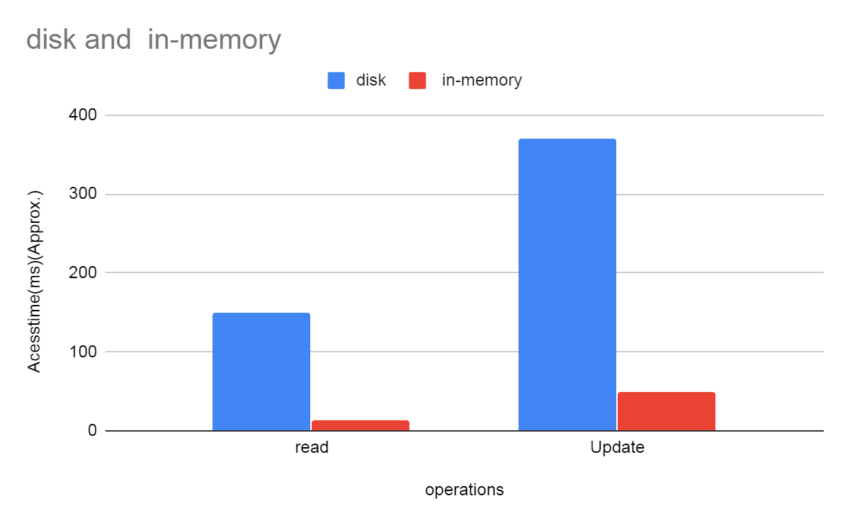
- System Architecture:

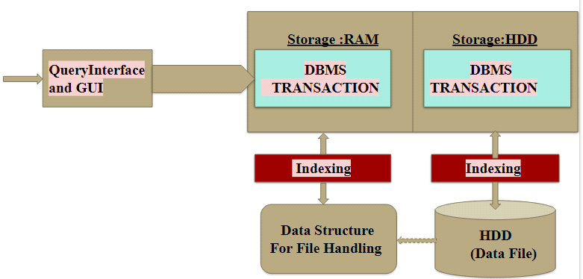
Objectives:
1.To retrieve data in short ample of time as compared to secondary storage.
2.To do data operations on both primary and secondary storage.
3.To compare the access time on both data storage.
Scope:
- Increasing efficiency of database operations like
- Read
- Deletion
- Update
- Measuring database operations rate for IMDB and HDD stored database.
- A novel approach for fast dataset mapping between IMDB data structure and HDD database
Future Scope:
● Designing and implementation of more robust multi-operations algorithm for efficient database information retrieval.
● To enhance the efficiency of information retrieval in Big-Data, Data Marts etc.
● To reduce the data analysis time in heavy computing concepts like Machine Learning, AI based applications.
● Useful in Distributed Systems.
● Applications in medical devices.
3.4 Methodology:
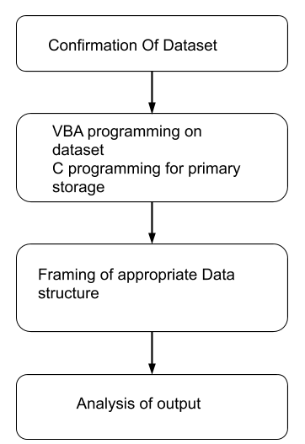

Confirmation of Dataset:
Coming on the types of Data Sets, we define them into three categories namely, Record Data, Graph-based Data, and Ordered Data. But in our project we considered the student record data having attributes Name of students,10th maks,12th marks, Course, passing year and branch. Apart from these types of files also plays an important role in inmemory database as which file format support both storage. Therefore we considered xls file.

VBA programming on dataset:
Excel VBA stands for Visual Basic for Applications. It is a programming language which is used to develop programs within Excel. It can turn complex or time-consuming tasks into automated processes, saving time and improving the quality of reporting.

C programming for primary storage:
As project is totally based on memory, appropriate language should be considered. There are many languages available with many functions like Java, Python, c, etc. Java is more robust as compared to C but more on that our primary concern was memory allocation. C is language has a rich library which provides a number of built-in functions. It also offers dynamic memory allocation. C implements algorithms and data structures swiftly, facilitating faster computations in programs.
For ex, “free” method is used to dynamically deallocate the memory. The memory allocated using functions malloc() and calloc() are not de-allocated on their own. Hence the free() method is used, whenever the dynamic memory allocation takes place. It helps to reduce wastage of memory by freeing it

Framing of data structure:
As we know, a data structure is a data organization, management, and storage format that enables efficient access and modification. Here we need to convert datafile stored in secondary storage to the appropriate data structure to store the data into the primary memory. but data structure which takes minimum time complexity and space complexity has to be considered. There are many data structures like arrays, linked lists, trees, graphs, etc.
Among this tree is good for large data as it manipulate hierarchical data, make information easy to search, manipulate sorted lists of data.

Analysis of output:
As programming done with specific number of records, some test cases should be evaluated. This work can be done by varying the number of records and changing the size of an attributes, changing the primary key, etc. to calculate the access time in each case and compare this output to finalise the result.

CHAPTER 4 : implementation plan
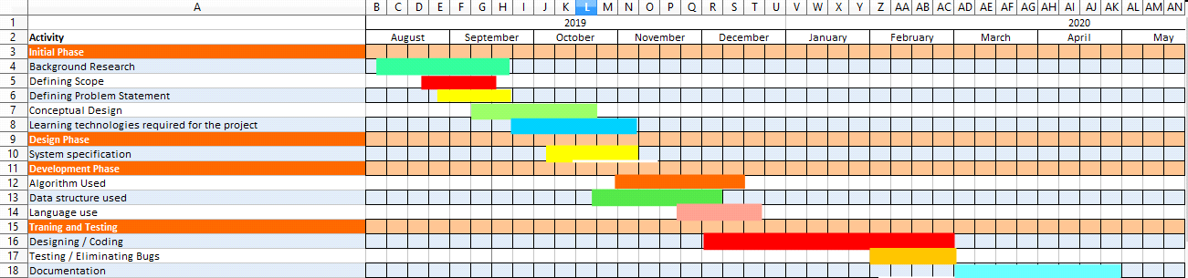

1.BACKGROUND RESEARCH:
We have completed the background research of our project such as what is in memory database and what is the need for its implementation by the mid of September.
2. DEFINING SCOPE:
We have also defined the scope of our project such as the areas where it will be used and the operations performed using IMDB in the month of September as well.
3. DEFINING PROBLEM STATEMENT:
We have defined the problem statement of the project by the end September.
4. CONCEPTUAL DESIGN:
We have finalized the architecture of the project by the end of October.
5. LEARNING TECHNOLOGIES REQUIRED FOR THE PROJECT:
We have learned the Visual Basic programming and advance C programming languages by the end of October.

6. ALGORITHM USED / DATA STRUCTURE:
We will finalize the data structure and the indexing technique by the month of December.
. Data Structure : Example: B-Tree which will be required to transfer the massive amount of data from secondary memory (HDD) to primary memory(RAM).
.Indexing Technique : We will have to use a suitable indexing technique Example: Clustered Indexing for the fast retrieval of information from a huge amount of data.
7. LANGUAGE USE:
We will finalize the programming language which will be used in our project by the mid of December.
8. CODING / TESTING:
We will be completing the coding and testing part of our project by the end of February.
9. DOCUMENTATION:
We will be completing the final documentation of our project by the end of April.

conclusion

IMDB's shows the great results when we deal with massive amount of data and we can retrieve data in short amount of time as compared to the secondary storage
We are performing the operations i.e Read, Update and Delete on both primary memory and secondary memory. We will then compare the access time on both data storage.
We will be working on various test cases, Example:
- First we will perform the operations on 10000 elements in a dataset and compare the access time.
- Then we will increase the elements in our dataset to 100000 and will perform the operations on them , then we will compare the access time.
- Likewise we will be comparing the results.

references
[1.] Intel and IBM Collaborate to Double In-Memory Database Performance intel 2009 http://communities.intel.com/docs/2985,Intel Inc.
[2.] J. C. Corbett, J. Dean, M. Epstein, A. Fikes, C. Frost, J. J. Furman, S.Ghemawat, A. Gubarev, C. Heiser, P. Hochschild, W. Hsieh, S. Kanthak, E. Kogan, H. Li, A. Lloyd, S. Melnik, D. Mwaura, D. Nagle, S. Quinlan, R. Rao, L. Rolig, Y. Saito, M. Szymaniak, C.Taylor R. Wang, and D. Woodford. Spanner: Google’s globally distributed database. In OSDI’12: Proceedings of the 10th USENIX conference on Operating Systems Design and Implementation,pages 251–264, Berkeley, CA, USA, 2012. USENIX Association.
[3.] P. M. Bober and M. J. Carey. “multiversion qeury locking”. 1992 In Proc. of the 18th Conference on Very Large Database,.
[4.] From The In Memory Database System Experts at Mc Object' https://www.mcobject.com/in_memory_database/
[5.]Enabling Real-Time Analytics With Database In- Memory,https://blogs.oracle.com/in-memory/join-processing-with- database in-memory

ACKNOWLEDGEMENT

In the present world of competition there is a race of existence in which those are having will to come forward succeed. Project is like a bridge between the theoretical and practical working. With this willing we have joined this particular project. First, of all we would like to thank the supreme power the Almighty God who is obviously the one has always guided us to work on the right path. Without his grace this project could not become a reality. We are feeling oblige in taking the opportunity to sincerely thanks to Dr. Phiroz Shaikh for his generous attitude and friendly behavior and who has been always helping and encouraging us to make this project a reality. We have no valuable words to express our thanks, but our heart is full of the favors received from him. We also want to thank to all the staff members of our computer department for their generous attitude and helping nature.

Project Team Members :

1. Diana Dsouza B. E. – (22)
2. Aishwarya Jadhav B. E. – (28)
3. Tooba Khan B. E. – (32)

